**LAB # 10**

**Task # 1: An automotive company wants to identify and treat outliers in their "mtcars" dataset, which contains information about various car models. They suspect that certain car models might have outlier values in certain variables and want to analyze and handle them using Python. Perform the following outlier detection techniques.**

1. **Box Plot**
2. **Z-score**
3. **IQR range**
4. **Scatter plot**

**Solution:**

**Linking data:**

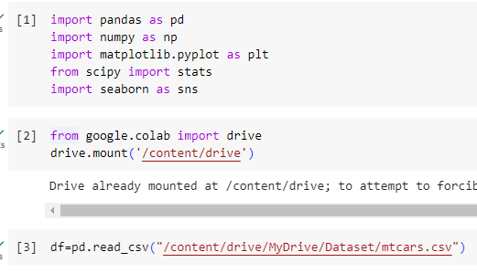

**Choosing Columns:**

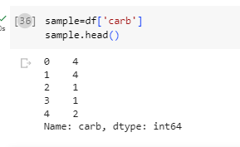

**Converting Column to relevant data type:**



1. **Detecting Outlier using Box Plot:**

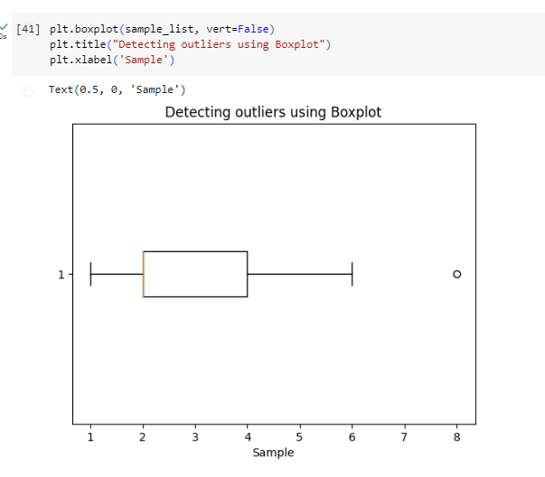

1. **Detecting Outlier using Z-score:**

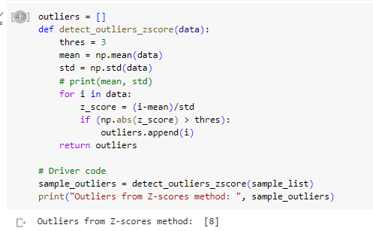

1. **Detecting Outlier using IQR range:**

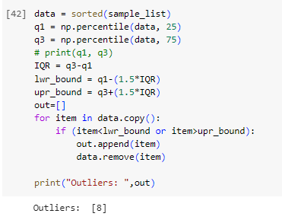

1. **Detecting Outlier using Scatter plot:**

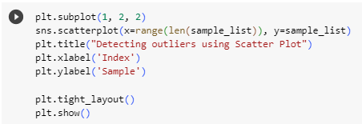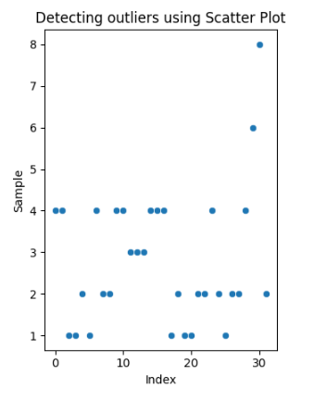

**Task # 2: An automotive company has identified outliers in their "mtcars" dataset and wants to treat them to ensure accurate analysis and modeling. They want to handle the outliers using Python. Performed the techniques that provided in the lab to treat the outliers.**

**Solution:**

1. **Trimming/Remove the Outlier:**

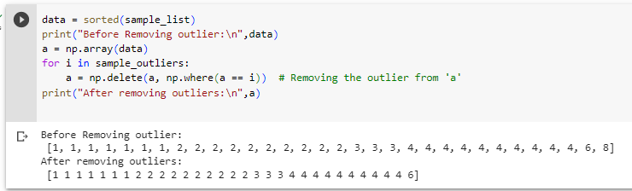

1. **By Using IQR Score:**

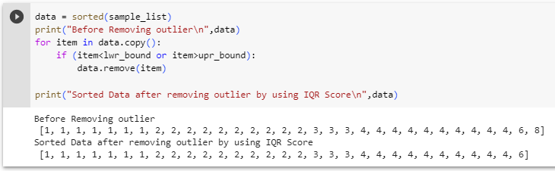

1. **Mean/Media Imputation:**

